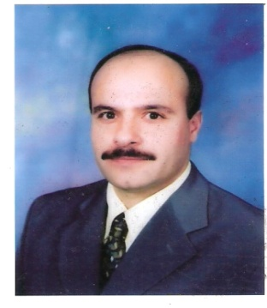 **Curriculum Vitae (CV)**

**Prof. Sadiq Kh. Alhayek (Ph.D), Jordanian**

**Faculty of Physical Education, The Un. Of Jordan**

**P.O. Box: 13617 , Code #: 11942, Amman- Jordan**

**Date of Birth: 1963, Tel: 00962795353414**

**Email.** [**dralhayek2@yahoo.com**](mailto:dralhayek2@yahoo.com)

**Present Status**:

* Vice Dean of Faculty of PE, The University of Jordan
* Assistant Secretary General of the Association of Faculties, Institutes, and Departments of Arabian Physical Education.

**Academic Qualifications:**

**2001 (Ph.D.)**  Curriculum & Instruction in PE , Ohio University, USA.

**1993 (M.A.)** Physical Training, The University of Jordan.

**1986 (B.A.)** Physical Education/Psychology, The University of Jordan.

**Awards: -**

**2006:** Distinguished Researcher Award, The Un. Of Jordan

**2013:** Distinguished Research Award, presented by of the Office of

Prince Mohammed Al Maktoumfor Sports Innovation, UAE.

**2014**: Distinguished Scientific Communication, Presented by

Collage of Alkalam – Karkook, Iraq, during Alsharja

Conference UAE.

**Publications and Conference Attendance:**

- (125) Scientific Research Papers were published in 24 Countries.

- (2) Task Books.

- (61) International, Arabs, and local conferences.

**Supervisor**: Supervised on 30 Master and Ph.D. Graduate students.

**Advisory Board** of 12 Journals of Research in Sport Sciences.

**Scientific Committee:** of 23 International, Arab, And Local Conferences.

**TECHNICAL & ADMINSTRATION EXPERIENCES:**

1988-1992: A member of Jordan Wrestling Federation (J. W. F).

1993-1994: A member of Jordan Basketball Federation (J. B. F).

2002-2004: A member of Technical committee of Jordan Olympic